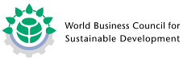

Partner Organisation of:

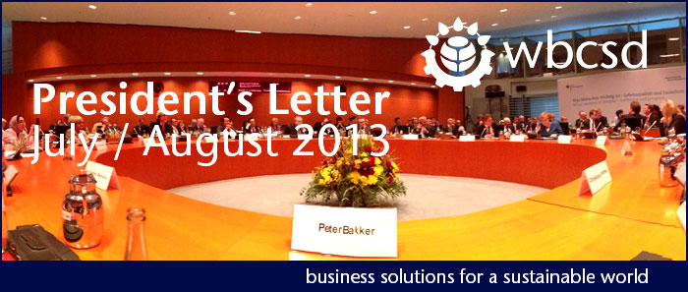

Dear Council Members,
The summer of 2013 will be remembered for its high temperatures and sometimes volatile weather. I hope you are finding some time for a relaxing holiday to recharge the batteries for a big second half of the year. In this brief newsletter, I kindly update you on the latest developments inside WBCSD.
As reported in the June 2013 President Letter, the ExCo has discussed changes in WBCSD’s governance and membership criteria. Prior to tabling these changes to the Council Member meeting in November, all these changes will be made available in a membership consultation that will run between August 13 and September 2. You will receive an email invitation this week and be provided access to the documents about which we will be seeking your input.
The ExCo will discuss the results of the consultation prior to submitting a final proposal for vote at the November 2013 Council Member meeting.

A second large Action2020 meeting was held in the middle of June in London. The SRC and WBCSD team has now completed the Executive Briefings on the scientific input. The last round of member comments is reviewed right now.
As mentioned in my June letter, the co-chairs have selected 9 priority areas [1 - Climate Change; 2 - Release of Nutrient Elements; 3 - Ecosystem degredation; 4 - Release of Harmful Substances; 5 - Fresh Water; 6 - Basic Needs and Rights; 7 - Skills and Employment; 8 - Well-being and Sustainable Lifestyles; and 9 - Nexus group Food]. For each of the nine areas working groups (WG) have been set up. Member companies participating in Action2020 have allocated themselves over the nine WG’s.
The WG’s have now completed the 2020 Must-Haves, which will form the basis for which the Action2020 project will identify and detail the Business Solutions. The Executive Briefs and Must-Haves have now been sent off to the co-chairs for comments and final approval by the end of August.
Each Working Group will, in the next 4 weeks, select three big ideas for Business Solutions to achieve their Must-Have. These 9*3 big ideas will be presented and discussed in the upcoming meeting in Washington DC on September 10.
At the moment we have scheduled 12 CEO-roundtable dinners where we will discuss the Action2020 Must-Haves and Business Solutions ideas with Council Members around the world. The first very successful dinner was held early August with Dr. Nishida of Toshiba as the host.
Nestle, L'oreal and EDF have decided to become core group Action2020 members. In total now 44 member companies participate. The project is still open for further participation if your company wishes to join Action2020 in it’s shaping phase.
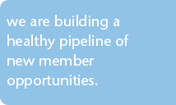
On July 2 and 3 Cement Sustainability Initiative members met in Heidelberg, Germany to discuss the implications of Action2020 for their work program. It was the first of the sector areas looking at the Action2020 agenda through the lens of their industry. Other sectors will be given this opportunity later this year as well.
Furthermore, we’ve spent a good part of the year visiting WBCSD members in India, Japan and the US. Membership engagement is developing positively as a result of these meetings and at the same time we are building a healthy pipeline of new member opportunities.
You should by now all have received the Save-the-Date for the annual Council Member meeting that is scheduled to take place on November 5 and 6 in Istanbul. I again kindly repeat my request to reserve the dates in your calendar.
The Action2020 agenda will be ready for presentation at this year’s meeting and thus the 2013 Council Member meeting will shape both WBCSD’s work and your company’s engagement with us.

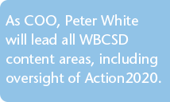
Peter White will join WBCSD on September 1 in the role of COO. Peter spent more than 20 successful years at Procter & Gamble (P&G), most recently in the role of Director of Global Sustainability where he led many substantial global initiatives and acted as WBCSD's LD. Through his long relationship with WBCSD as a member LD, Peter already knows our organisation and many of our people well. Prior to his period at P&G, Peter spent 14 years in full-time academic learning, research and teaching. He holds a PhD in Chemical Biology from Oxford University, an MSc in Applied Hydrobiology and an MA in Zoology. He is currently also Visiting Professor at the Newcastle Institute for Research into Sustainability, University of Newcastle.
As COO, Peter will lead all WBCSD content areas, including oversight of Action2020. The Focus Area and Business Application Managing Directors will report to the COO.
A second cluster of activities will be formed under our Chief Member Engagement and Policy Officer (CMEPO): Carina Larsfalten. This cluster is composed of Member relations, Member acquisition, our US and India offices, Government Relations, Regional Networks, Communications and Events.
Upon the arrival of Peter White, the WBCSD Management Team will consist of four members: Peter White as COO, Carina Larsfalten as CMEPO, Greg Davies as CFO and myself as President and CEO.
Warm regards,
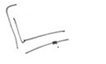
Peter Bakker

To unsubscribe from this newsletter please email communications@wbcsd.org putting "unsubscribe" in the subject.

